|  |  |  |
| --- | --- | --- |
| **LAB221Assignment** | **Type:** | **Short Assignment** |
| **Code:** | **J2.S.P0010** |
| **LOC:** | **20** |
| **Slot(s):** | **1** |

**Title**

Change background color of textarea.

**Background Context**

Working with table or charts, sometime we need to format the display of them like set background color for particular row/column.

In this assignment, you are required to make a java swing application (the design look like figure (1)). There are 4 buttons with background colors are: red, green, blue and cross button. The cross button can be used as toggle button to determine whether the background color is to be modified or the foreground.

**Program Specifications**

Create an application using java swing to create a frame look like (1)

**1. Main.java**

Make a frame look like description below.

***Function details:***

1. Display the GUI like below figure. **This is simple design and requires you to make that frame by your coding**.
2. When users clicks on these button do the corresponding task.

***Expectation of User interface:***

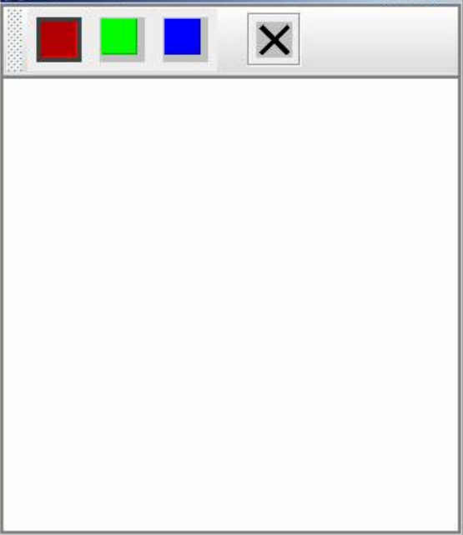 ***(1)***

**Guidelines**